WEEK 5 TASK BY RIDDHI MALHOTRA
--------------------------------------------TASK 1---------------------------------------
1.Explore the Power BI Interface.
Power BI provides an intuitive interface with three main views:
Report View for creating visualizations,
Data View for inspecting tables and columns, and
Model View for managing relationships between tables.
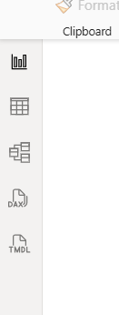
The ribbon at the top offers options to import data, transform it, and build dashboards, making it easy to navigate through the analytics workflow.
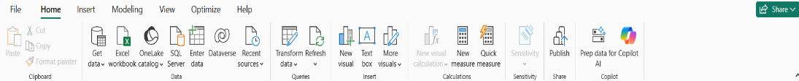

2.Import a Suitable Dataset
The Covid-19 dataset (Covid19 India Jan–Mar 2020) was imported into Power BI using the Get Data → Text/CSV option. This allowed the raw data to be loaded directly from the CSV file, with a preview shown before finalizing the import. The dataset contains information about confirmed cases, cured patients, and deaths across different states and dates.
3.View the Imported Data
Once imported, the dataset was examined in the Data View. Each row represents Covid-19 case records for a particular state on a specific date. Columns such as ConfirmedIndianNational, ConfirmedForeignNational, Cured, and Deaths provide numerical values, while Date and State/UnionTerritory provide categorical and time-series information.
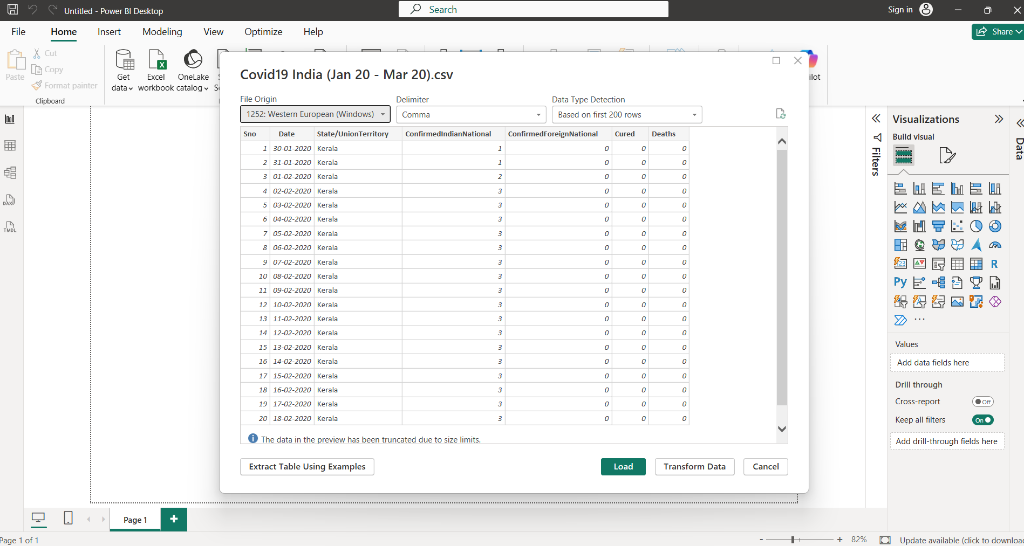

4.Identify the Available Tables and Columns
The dataset consists of a single table with columns: Serial Number, Date, State/UnionTerritory, ConfirmedIndianNational, ConfirmedForeignNational, Cured, and Deaths. These columns capture essential details about the spread and impact of Covid-19 in India during the early months of 2020.

5.Check the datatype of each column

6.Explain the basic purpose of Power BI in Data Analytics.
The basic purpose of Power BI in Data Analytics is to help transform raw data into meaningful insights through interactive visualizations and reports. It allows users to easily import data from different sources, clean and prepare it, and then create dashboards that reveal patterns, trends, and relationships. Power BI makes complex data understandable by presenting it in charts, graphs, and maps, enabling better decision-making. In short, it is a tool designed to turn data into clear, actionable business intelligence that supports analysis, monitoring, and strategic planning.

-----------------------------------TASK 2----------------------------------------------
1.Inspect the Imported Dataset
The initial stage of working with Power BI, where importing of the CSV file named Covid19 India (Jan 20 – Mar 20) is done. In this step, Power BI displays a preview of the raw dataset before loading it into the workspace. The table includes columns such as Sno, Date, State/UnionTerritory, ConfirmedIndianNational, ConfirmedForeignNational, Cured, and Deaths. This step highlights the data import process, where you connect to a source file and verify its structure before analysis.

2.Identify Missing or Incorrect Values
This shows the Power Query Editor in Power BI, which is used for cleaning and transforming the imported dataset. Here, you can see profiling bars above each column that indicate data quality, along with applied transformation steps listed on the right. These steps include promoting headers, changing data types, and renaming columns (for example, Sno was renamed to Serial Number). The preview again shows Kerala’s Covid-19 data, but now it is structured and formatted correctly. This step represents the data preparation stage, where raw data is refined to ensure accuracy and consistency before visualization.

Column Distribution → Shows how values are spread across a column, highlighting frequency and patterns.
Column Quality → Displays the percentage of valid, error, and empty values in a column.
Column Profile → Provides summary statistics (like count, min, max, average) for the column’s data.

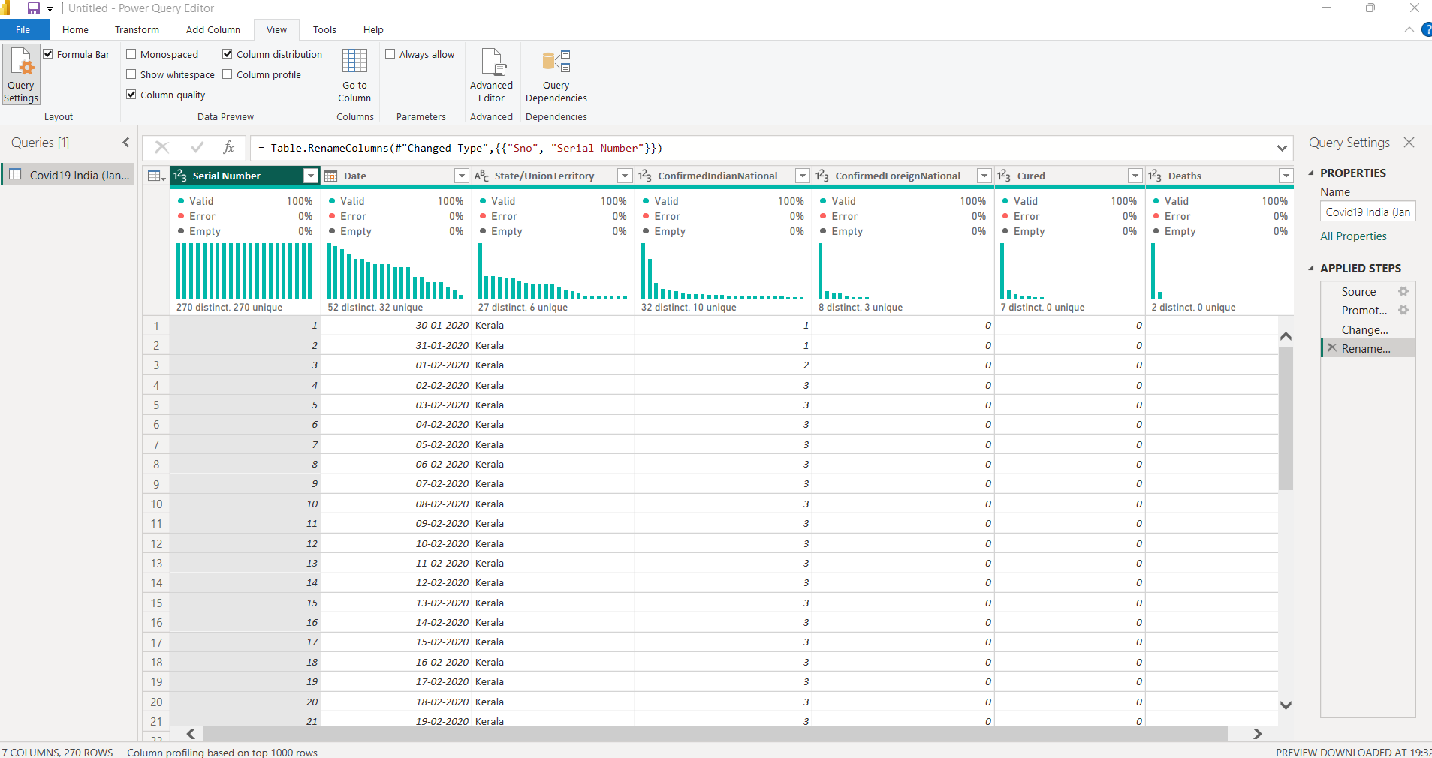
3.Change Incorrect Data Types
The data types of columns were corrected to match their content. The Date column was converted to a proper Date type, while numerical columns such as ConfirmedIndianNational, ConfirmedForeignNational, Cured, and Deaths were set as Whole Numbers. The State/UnionTerritory column was kept as Text. This step ensured accurate calculations and visualizations.
4.Rename Columns Where Appropriate
Columns were renamed for clarity and readability. For example, Sno was renamed to Serial Number to make the dataset more understandable. Clear column names help in creating meaningful reports and dashboards.
5.Apply Suitable Transformations to Prepare the Dataset for Analysis Finally, transformations such as promoting headers, standardizing state names, and ensuring consistent formatting were applied. These steps prepared the dataset for accurate analysis and visualization, making it reliable for generating insights in Power BI.

This image shows the Query Settings panel in Power BI’s Power Query Editor for the Covid-19 dataset. It lists the applied steps taken during data preparation: connecting to the source file, promoting headers, changing data types, and renaming columns. These steps document the cleaning process, ensuring the raw Covid-19 data is properly structured and ready for analysis.
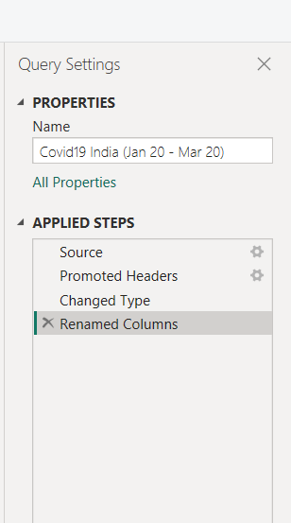
------------------------------------TASK 3--------------------------------------------
1.Using multiple tables for task 3:
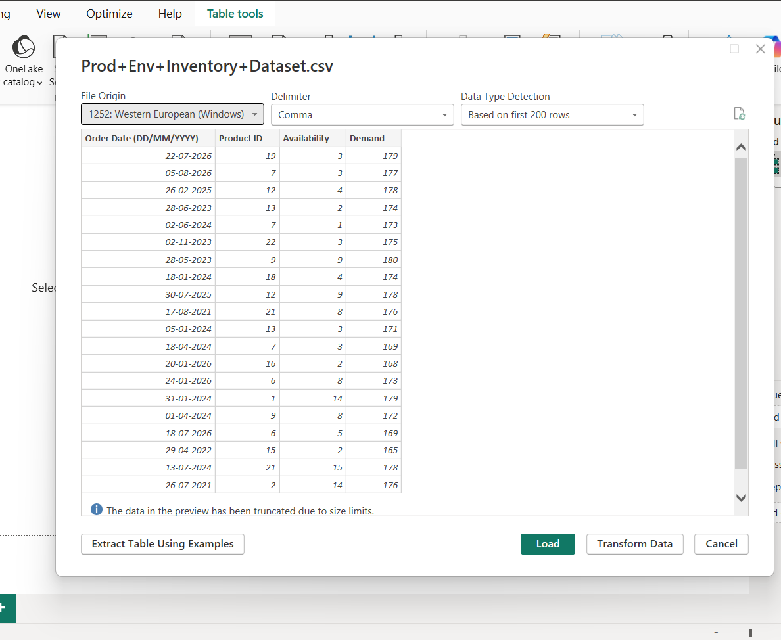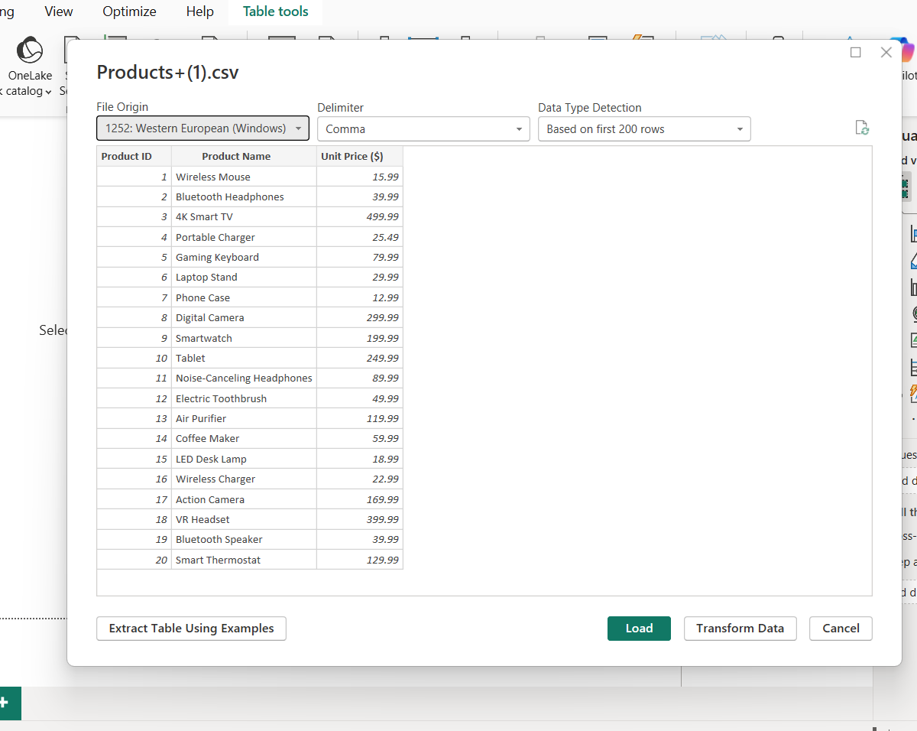

2.Identify Common Columns Between Tables
The Product ID column is present in both the Product Inventory table and the Products table. This acts as the key for linking product details with inventory and demand records.
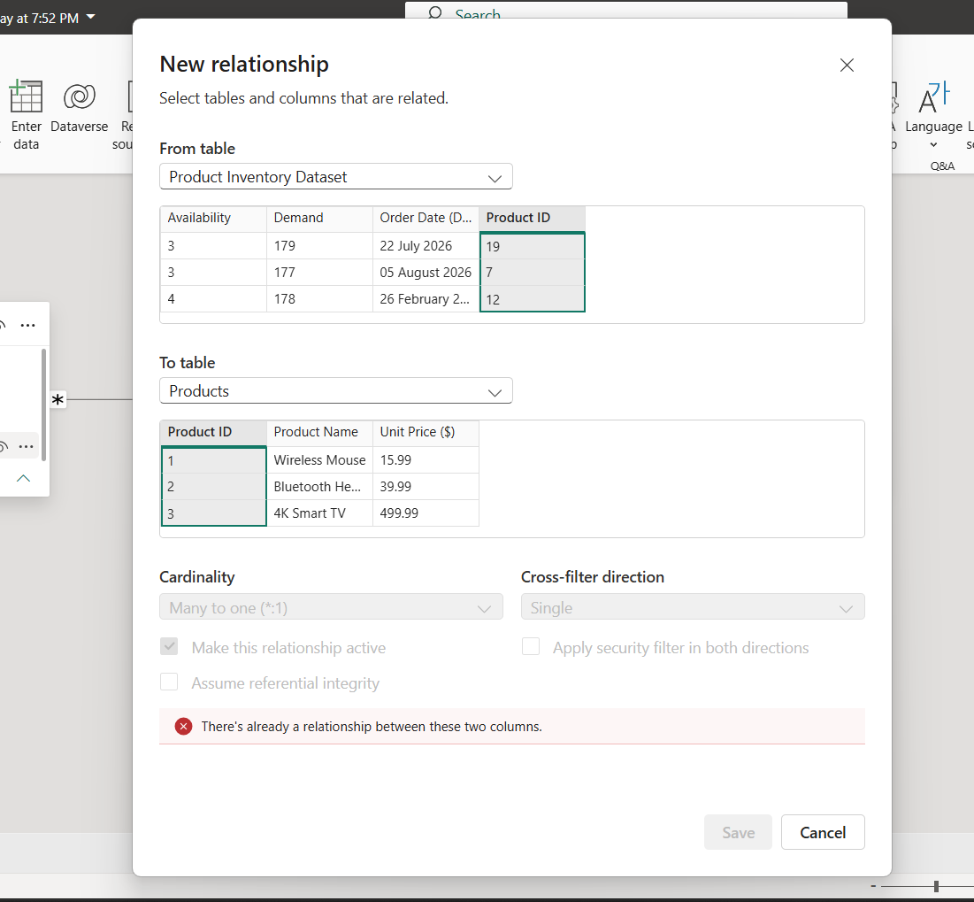
3.Create relationships between relevant tables.
A relationship is created between Product ID in the Inventory table and Product ID in the Products table. This connects product-level information (name, price) with order-level information (availability, demand).
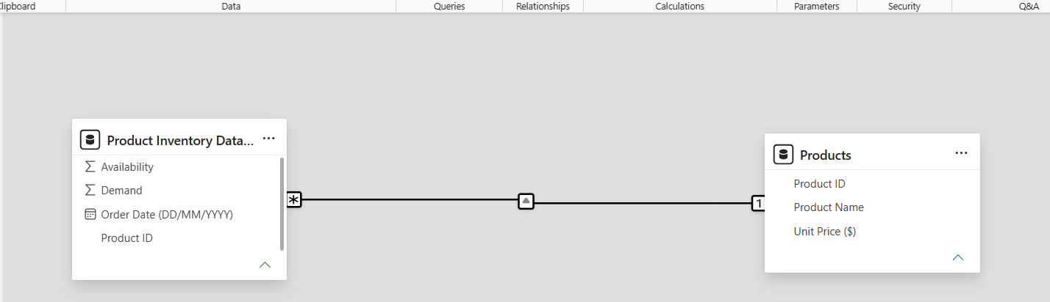
4.Select the Appropriate Relationship Type
The relationship type is one-to-many. Each product in the Products table (one side) can appear multiple times in the Inventory table (many side), since demand and availability are tracked across different dates.
5.Create a basic data model.
6.Explain the Relationships Created
The relationship ensures that when analyzing demand or availability, you can also view product names and prices. For example, you can create a visualization showing total demand for each product name, or compare availability trends against unit prices. This makes the analysis richer and more business-oriented.

------------------------------------TASK4---------------------------------------
1.Total Sales = SUMX('Product Inventory Data', 'Product Inventory Data'[Demand] * RELATED(Products[Unit Price ($)]))

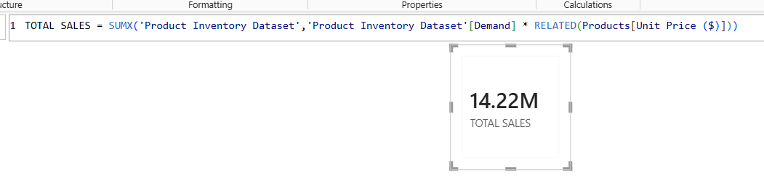

2. Average Sales = AVERAGEX('Product Inventory Data', 'Product Inventory Data'[Demand] * RELATED(Products[Unit Price ($)]))

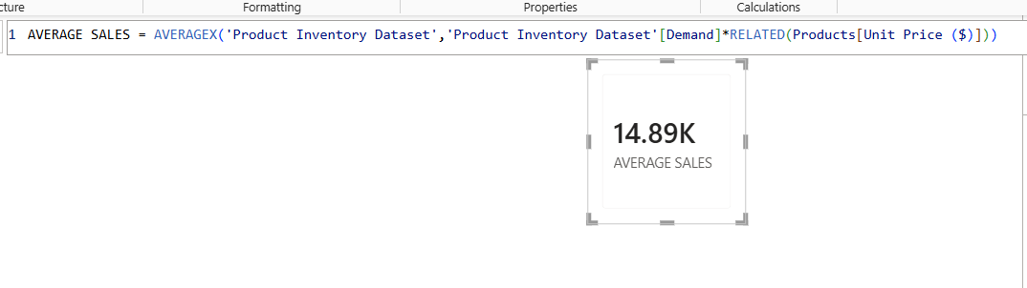

3. Total Records = COUNTROWS('Product Inventory Data')

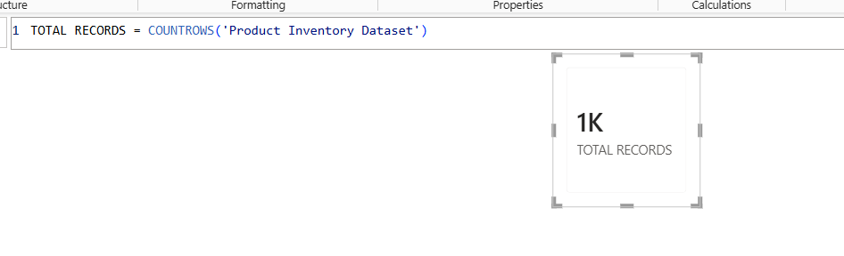
4. Max Demand = MAX('Product Inventory Data'[Demand])
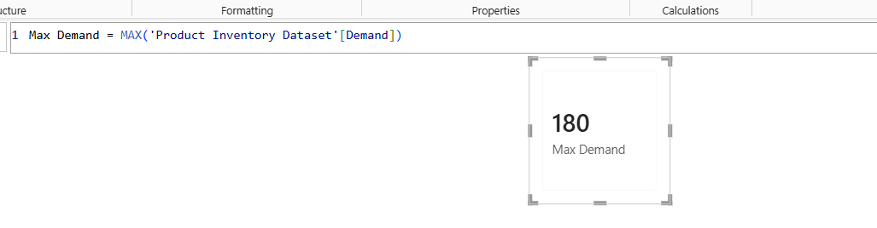

5. MIN Demand = MIN('Product Inventory Data'[Demand])
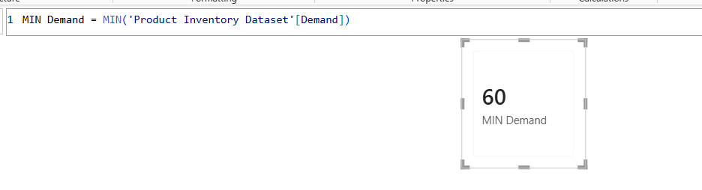

6. Availability % = DIVIDE(SUM('Product Inventory Data'[Availability]), SUM('Product Inventory Data'[Demand]), 0)
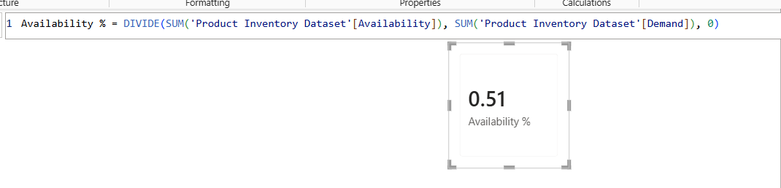

DAX CREATED IN TOTAL:
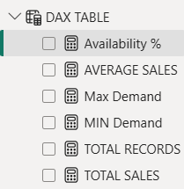
DAX MEASURES PAGE:
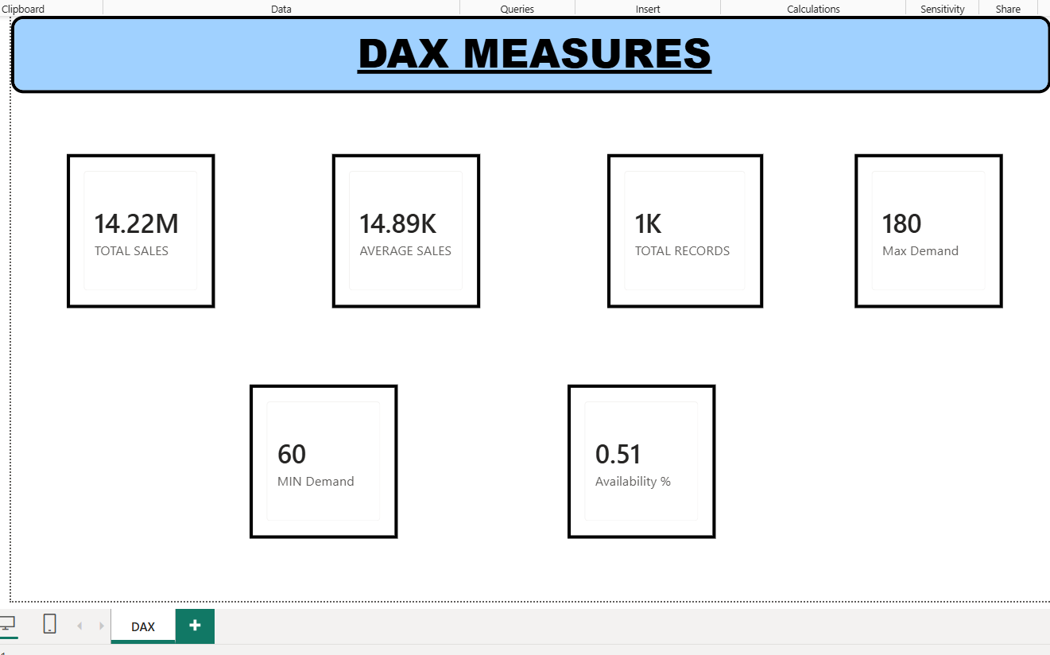

---------------------------------------TASK5---------------------------------------
1.Bar chart
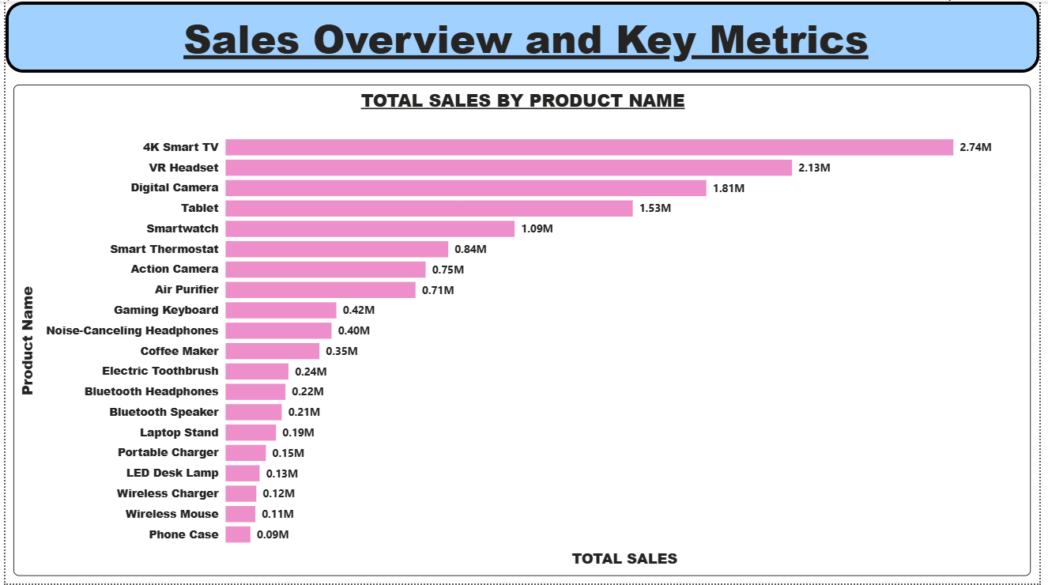
A bar chart was created to display Total Sales by Product Name. The Product Name field from the Products table was placed on the axis, and the DAX measure Total Sales was used as the value. This visualization clearly shows which products generated the highest revenue. The chart was titled “Total Sales by Product” to make its purpose clear.

2.Column chart
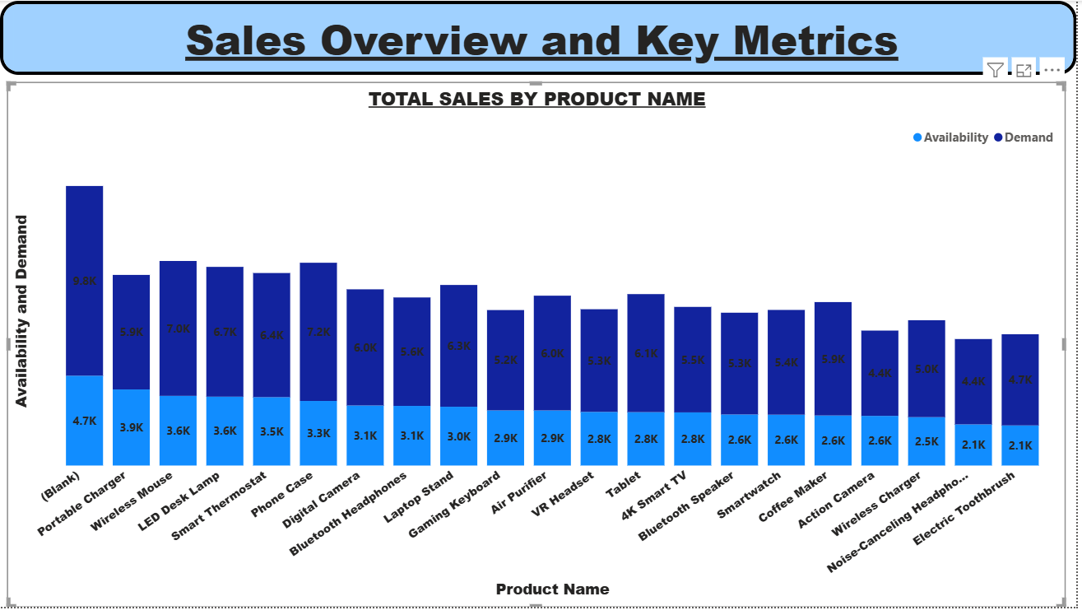

This chart is a stacked bar chart comparing product availability and demand. Each product is shown along the axis, with two bars: one for stock available and one for customer demand. It highlights that demand is generally higher than availability, showing supply gaps for items like the Phone Case and Wireless Mouse, while some products such as the Action Camera have demand closer to availability. In short, it gives a clear overview of how supply meets demand across products.

3.Line chart
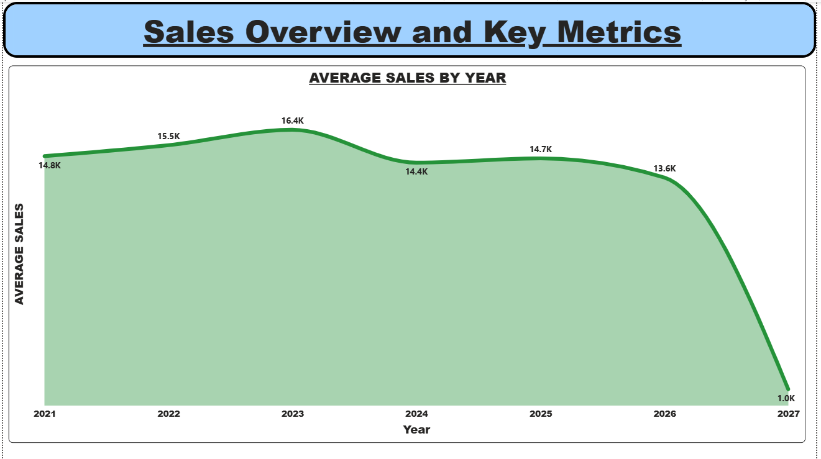

A line chart was used to represent the Average Sales over Time. The Order Date field was placed on the axis, and Average Sales was used as the value. This visualization highlights how sales varied across different months and years, making it easy to identify peaks and declines. The chart was titled “Average Sales by year”.

4. Pie/Donut chart
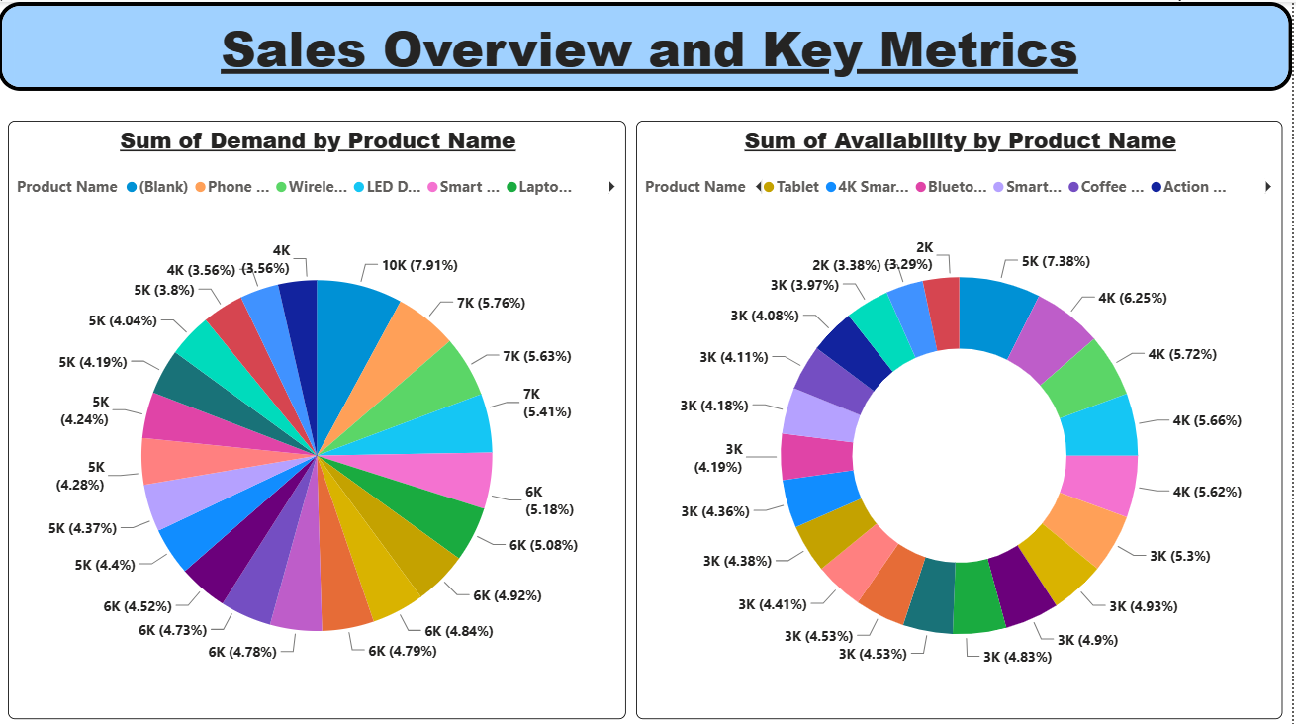

This uses donut and pie charts to compare product demand and availability. The chart on the left shows the sum of demand by product name, with each product represented as a colored slice and labeled with values and percentages. The chart on the right shows the sum of availability by product name, also broken down by product categories with values and percentages. Together, these visuals provide a clear overview of how customer demand is distributed across products and how available stock compares, making it easy to spot imbalances between demand and supply.

5.TABLES/MATRIX
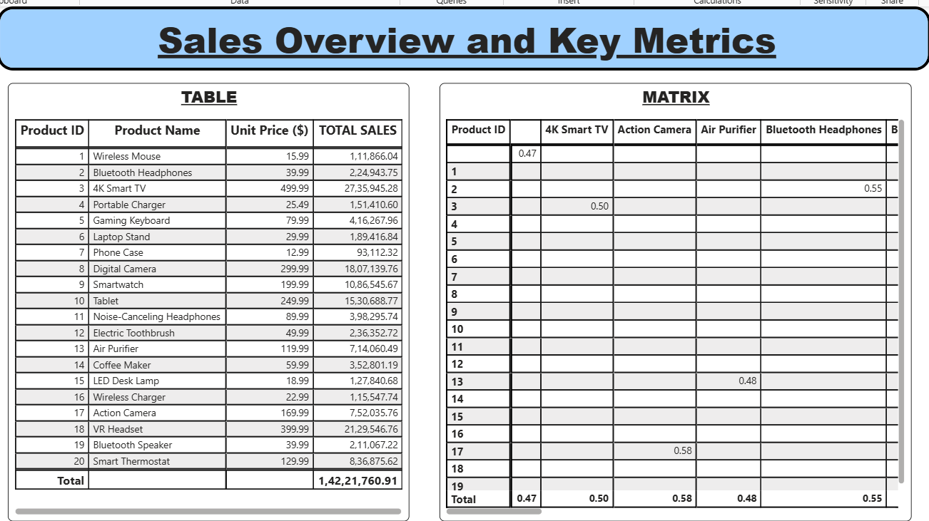
This visualization combines a table and a matrix to present product sales and comparative metrics.
The table lists each product with its ID, name, unit price, and total sales, giving a clear breakdown of revenue contributions. For example, high-value items like the 4K Smart TV and VR Headset show significantly larger total sales compared to smaller items such as the Phone Case or LED Desk Lamp.
The matrix section highlights relationships between selected products, showing numeric values that represent correlations or performance comparisons. Together, the table and matrix provide both detailed product-level insights and comparative analysis, making it easier to evaluate overall sales performance and identify product relationships.

6.KPI/CARD
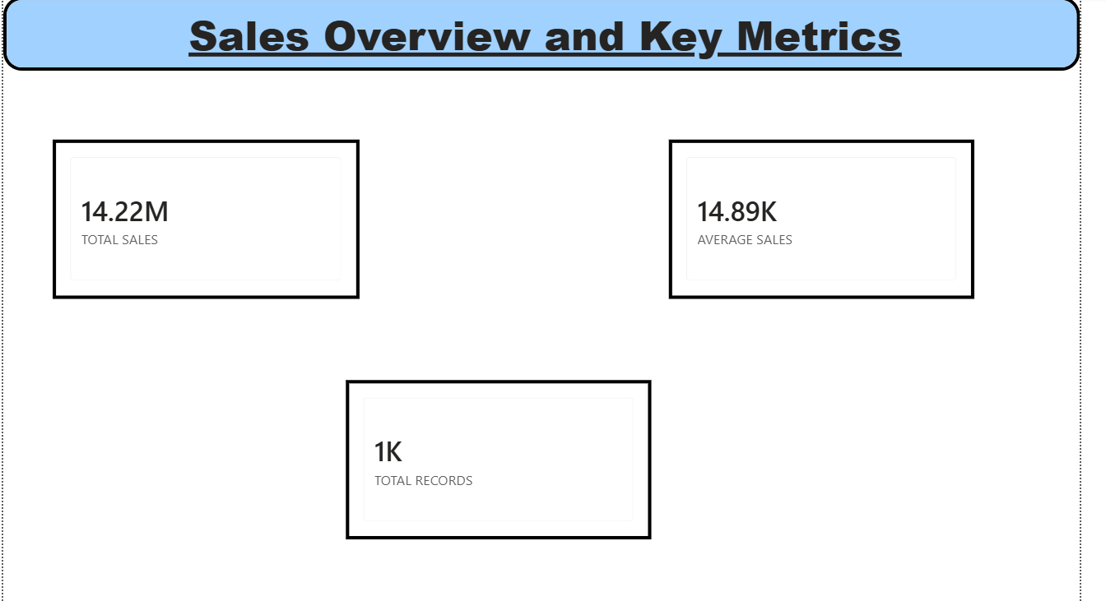
Card visuals were used to display key metrics such as Total Sales, Average Sales, and Total Records. These cards provide quick insights into overall performance at a glance. Each card was given a meaningful title, such as “Total Sales”, “Average Sales Value”, and “Total Transactions”, ensuring clarity.

--------------------------------TASK6--------------------------------------------------
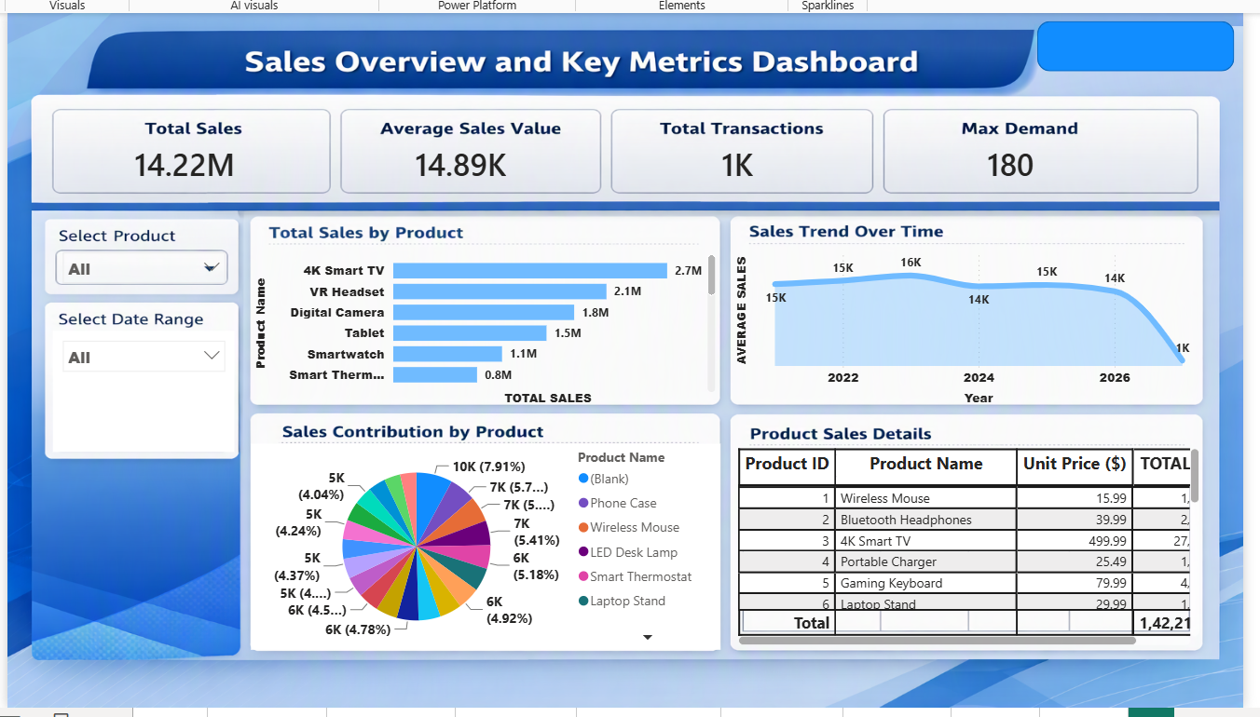

The Sales Overview and Key Metrics Dashboard was designed in Power BI to provide a clear, interactive view of product performance and business insights.
At the top, four KPI cards summarize the most important metrics: Total Sales, Average Sales Value, Total Transactions, and Max Demand. These cards give users a quick snapshot of overall performance before exploring detailed visuals.
Two slicers — Select Product and Select Date Range — were added to enable filtering across the dashboard. This interactivity allows users to drill down into specific products or time periods, making the analysis dynamic and user-controlled.
The main section of the dashboard contains four different visualizations arranged neatly for clarity:
- A bar chart showing Total Sales by Product, highlighting top-performing items like the 4K Smart TV and VR Headset.
- A line chart displaying the Sales Trend Over Time, which helps identify fluctuations and seasonal patterns.
- A pie chart illustrating Sales Contribution by Product, providing a percentage breakdown of how each product contributes to overall sales.
- A table listing Product Sales Details with columns for Product Name, Unit Price, Demand, and Total Sales, offering granular insights.

The layout was organized with KPI cards at the top, slicers on the side, and visuals arranged in a grid below. Titles and labels were applied consistently to ensure readability. This structure fulfills all assignment criteria: 3+ KPI cards, 4+ visualizations, 2+ slicers, appropriate titles/labels, and a professional layout. The dashboard is fully interactive, enabling users to filter and explore data effectively.

-----------------------------------------TASK 7----------------------------------------
1.At least 5 meaningful insights.
Business Insights
- Total Sales Performance: The dashboard shows overall sales reaching 14.22M, indicating strong revenue generation across product categories.

- Average Sales Value Stability: The average sales value remains around 14–16K over the years, suggesting consistent pricing and demand patterns.

- Top Performing Products: The 4K Smart TV (2.7M) and VR Headset (2.1M) are the highest contributors to sales, highlighting them as flagship products.

- Lowest Performing Products: Items like Smart Thermostat (0.8M) and smaller accessories (e.g., Phone Case, LED Desk Lamp) contribute the least, showing weaker demand.

- Sales Trend Over Time: The line chart reveals fluctuations, with peaks in 2023 and dips in 2024 and 2026. This indicates possible seasonal demand or market saturation.

2.Important trends or patterns identified from the dashboard.
The dashboard reveals several important patterns in sales performance.
First, the average sales value has remained relatively stable between 14K–16K across multiple years, even though total sales fluctuate. This suggests that while the number of transactions may vary, the business consistently attracts customers willing to spend at a similar price point, indicating a premium-oriented product strategy.
Another clear trend is the heavy reliance on high-value electronics such as the 4K Smart TV and VR Headset. These products dominate overall sales contribution, showing that the company’s revenue is concentrated in a few flagship items. While this is positive for short-term profitability, it also highlights a risk: if demand for these products declines, overall sales could be significantly impacted.
The line chart of sales over time shows cyclical dips, particularly in 2024 and 2026, which may point to seasonal demand fluctuations, market saturation, or external factors like competition. Identifying these cycles is crucial for planning promotions and inventory management.
Finally, the transaction volume of 1K compared to the high total sales indicates that the business relies on fewer but larger purchases. This reinforces the premium positioning but also suggests that expanding into mid-range products could help increase transaction counts and broaden the customer base.

3.Highest and lowest performing categories where applicable.

Highest Performing Categories
- 4K Smart TV: With sales of 2.7M, this product is the single largest contributor to overall revenue.
- VR Headset: Generating 2.1M, it is the second-highest performer, showing strong demand in immersive technology.
- Digital Camera (1.8M) and Tablet (1.5M) also perform well, reinforcing the dominance of premium electronics in the sales mix.

Lowest Performing Categories
- Smart Thermostat: At 0.8M, this product shows the weakest demand among major categories.
- Accessories such as Phone Case, LED Desk Lamp, and Laptop Stand contribute very small percentages (around 4–8% each), highlighting limited customer interest in lower-value items.
- These categories lag far behind the flagship electronics, suggesting they are not core revenue drivers.

4. Business recommendations based on your findings.

- Strengthen High-Performing Categories Since premium electronics like the 4K Smart TV (2.7M) and VR Headset (2.1M) are driving the majority of sales, the company should continue to invest in these flagship products. Strategies could include targeted marketing campaigns, ensuring sufficient inventory, and bundling these items with accessories to increase overall transaction counts. This will maximize revenue from proven best-sellers while also boosting sales of related products.

- Revitalize Low-Performing Categories Products such as the Smart Thermostat (0.8M) and smaller accessories (Phone Case, LED Desk Lamp, Laptop Stand) are underperforming. To improve their contribution, the business should introduce promotional offers, discounts, or bundle deals with high-value items. Additionally, gathering customer feedback could help identify whether pricing, product features, or awareness are limiting demand, allowing adjustments to better meet customer needs.

